**Example of Multiprocessing #2:**

This program uses multiprocessing to calculate and determine prime numbers and then append those numbers to a list.

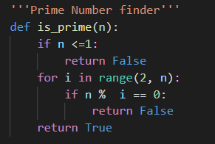

It uses a simple algorithm to determine if the given number is prime or not.

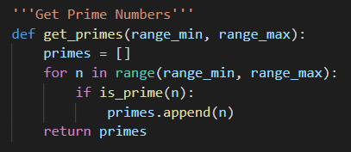

This function is used to find all of the prime numbers within a given range of numbers and appends them to a list.

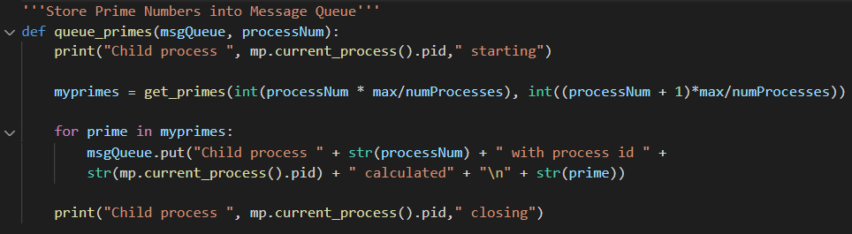

This is the driver function for this program. It creates a list using the get_primes function and then places each of those prime numbers into a queue which will be accessed by the specific process that is calling this function at the time.

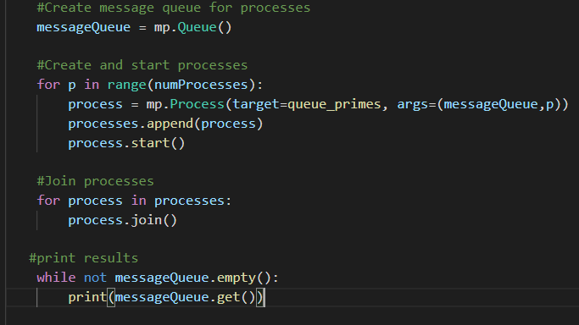

This is the main function for this program. It creates a queue using the multiprocessing module and then creates the processes that will be used to queue the primes. Once a process is created, it is appended to a list and then the process is started. Then we join each of the processes using the built in join() method.